Business Education/Computers

Stay positive work hard and MAKE IT HAPPEN!

**(Dreams, Goals, Careers)**

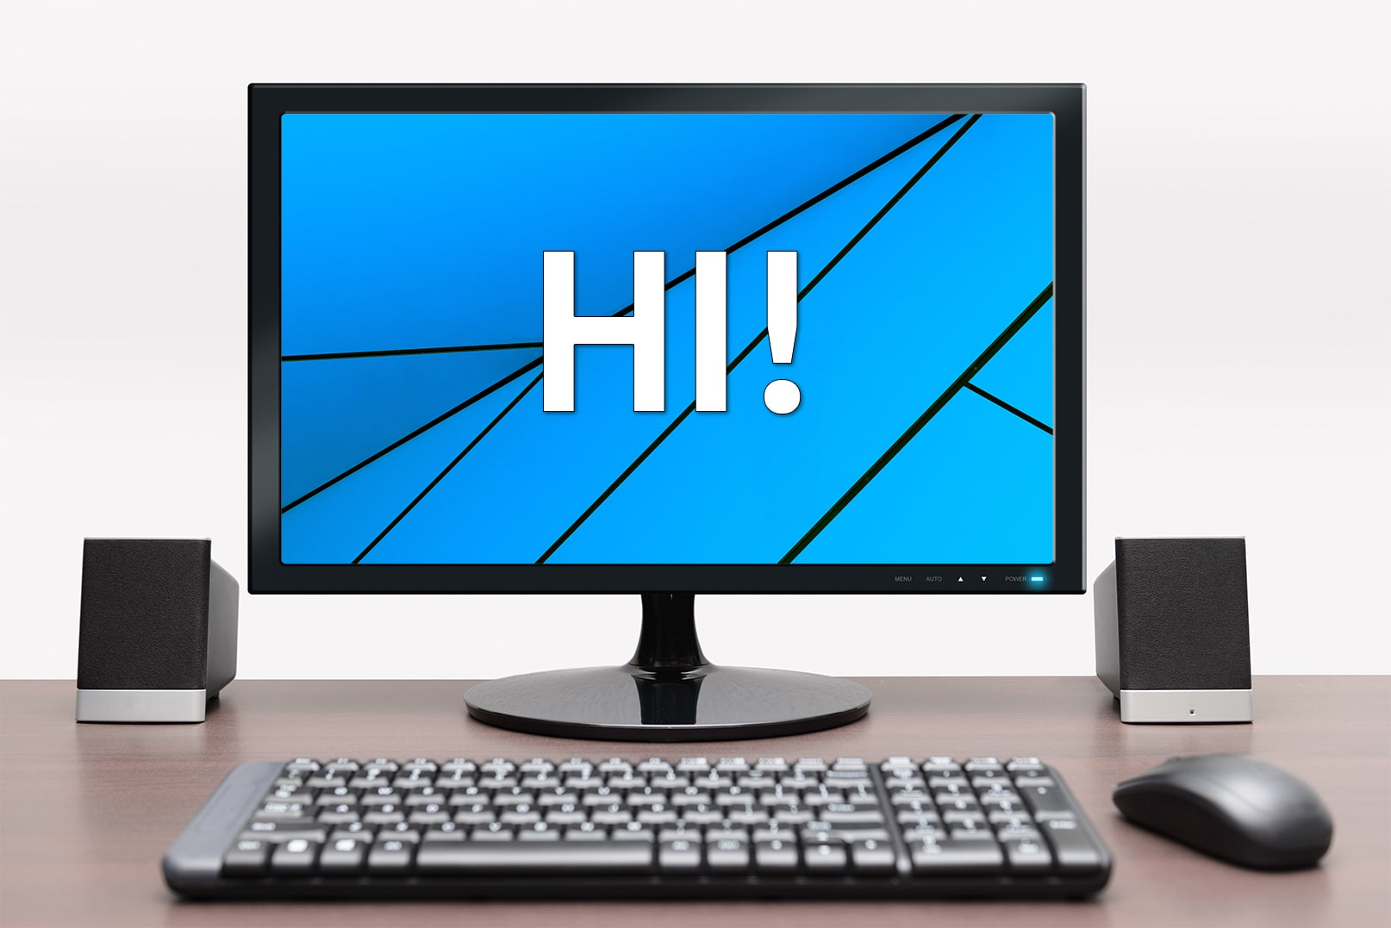

[This Photo](https://askleo.com/first-things-to-do-with-a-new-windows-computer/) by Unknown Author is licensed under [CC BY-NC-ND](https://creativecommons.org/licenses/by-nc-nd/3.0/)